**Child labor applied information system**

|  |  |  |  |
| --- | --- | --- | --- |
| **E-mail** | **Department\Section** | **Full Name** |  |
| [Verena.samuel2018@feps.edu.eg](mailto:Verena.samuel2018@feps.edu.eg) | Economics\Arabic | Verina Samuel Eissa | **Member 1** |
| sarah.ashraf2018@feps.edu.eg | Economics\Arabic | Sarah Ashraf Abdelmoniem | **Member 2** |
| nermin.tariq2018@feps.edu.eg  Top of Form | Economics\Arabic | Nermeen Tarek Abd Elazeem | **Member 3** |
| Doha.atef2018@feps.edu.eg | Statistics/Arabic | Doha Atef Hassan | **Member 4** |
|  |  |  |  |
|  |  |  |  |

**3. Introduction:**

Child labor issue is one of the most dangerous phenomena that threaten the Egyptian society in the last few years. According to the estimates of the international labor organization (ILO); about 2.2 million children are working in Egypt, which make up about 26%. According to the Central Agency for Public Mobilization and Statistics (CAPMAS) national child labor survey indicates that 1.6 million children are engaged in dangerous, unlawful forms of work (A 2013 study).

**4. System analysis:**

**4.1. Problem definition**

Egypt has a significant number of working children and should develop an adequate system of child labor statistics and consider it a part of its national statistical program. To deal properly with this issue we must take into consideration the needs and the circumstances of the Egyptian society. The system should contribute to the development of the economic and social standards. We should collect data disaggregated by age, sex, school attendance, and geographical location. The system should also be provided with socio-economic characteristics of children such as education status, and the income of their household.

Overview the new system and determine its objectives:

Our system is mainly an application that anyone could use to report a working child anywhere all over Egypt. It will be easy to use: once users enter the application they'll find a form to fill about the working child. Needed information will be as follows:

1. Name of the child
2. Age
3. Sex
4. What do they do
5. Their location in detail
6. How many family members do they have, what are their jobs, where are they based
7. Education status of the child

After the user report the case, people working on the application will investigate it and do the needed to make this child focus on their education instead of working and worrying about their basic life needs by providing a suitable lasting source of income for the child and his/her family.

Based on the case, we will use one or more of the following options:

1. If the child has no parents, we'll link him to an orphanage to take care of him.
2. If the child has a parent or a family, we'll provide the parent with a job that's convenient for their abilities.
3. Based on the case, contact a charity to provide the child and their families with donations. For example: food, money, etc...

Objective:

Main purpose of the system is to eliminate the number of working children and provide them with a decent life and basic life needs.

Constrains:

1. Data may not be accurate. Children might be scared to provide a stranger their real information.
2. People might not be so cooperative. To overcome this we need to spread awareness about the importance of our project and how a simple act of them may save a child's life.

**4.2. Requirement Analysis**

1. **People**

The design, development, launching, and maintenance of any information system involves teams of people these people play different roles

1. The visionaries: in our system we can work with the Ministry of Social Solidarity to set the vision of the system.
2. System analysts: in our system we can work with social institutions and associations that support the idea of the system and have information about the working and homeless children and about the nature of their live so we can do a good analysis.
3. System designers: we will do a design for the analysis on papers so that we can program it on the computer.
4. Developers: we can work with programmers in coordination with the Ministry of Communications and Information Technology to develop our system.
5. Managers: we can put the system under the supervision of officials from the Ministry of Social Solidarity and from associations and social institutions where they work together to manage the system efficiently and ensure its effectiveness and ensure the arrival of aid to these children.
6. Users: the users will be all members of the people, as the system will be available to the public to add any data they have about these children as an attempt to help them and report their status.
7. Customers: they are these working children whose lives we want to improve, and the donors who will be responsible of them can also be considered customers.
8. **Technology**

Information technology (IT) includes hardware, software and telecommunication. They help us to collect and store data.

1. Hardware: we use computers, mobile phones, and laptops which collect, process, and store data.
2. Software: we depend on GPS software when storing data and use access to store and extract information.
3. Telecommunication: we need to connect hardware to each other through internet (online) as people need access to store child’s data on the application. It is less secure but we need all people to be able to store information about those children.
4. **Processes**

* We have to collect child’s databy filling the form on the application. It is necessary to have people’s approval to fill the form.
* It is essential to make sure that the data is correct from Ministry of Social Solidarity, to satisfy our information system and complete the processes.
* Classifications of children cases as they have families or not, classifications only appear to customers as charities and orphanages.

In case of a child have a family. Charites contact their family and try to provide suitable jobs for parent.

Another case, if a child does not have a family, orphanage will take the child.

**Security policies:**

* Data of children only appear to customers (orphanages, charities, etc…..).
* Anyone can fill the form but not edit it.
* Only managers can edit the data especially after checking the data with the ministry.
* The system doesn’t require a password.

**4. Database**

We need to put data in database to be able to extract information from it

so to create our data base we need to collect data about working children (their names, ages, national ID (which are unique), birthplaces, their wages, addresses, job, gender and educational level) and on the families that they take care of (their national ID(which are unique), names, ages, relationship with the child and their gender) and about the places in which these children work (address (which are unique), nature of the work, the number of children working in it, the name of the employer and the phone number) and about the donors who will sponsor these children (their names, ages, addresses, phone numbers, national ID(which are unique) , monthly donation amount, and emails) and about the charities that will link between the donors and the children (their ID (which are unique) and their names, Phone numbers, emails, addresses, name of the manager, date of their creation, and their account number in the bank)

* DBMS : we will use Microsoft Access to make the database and manage it

**5. System design:**

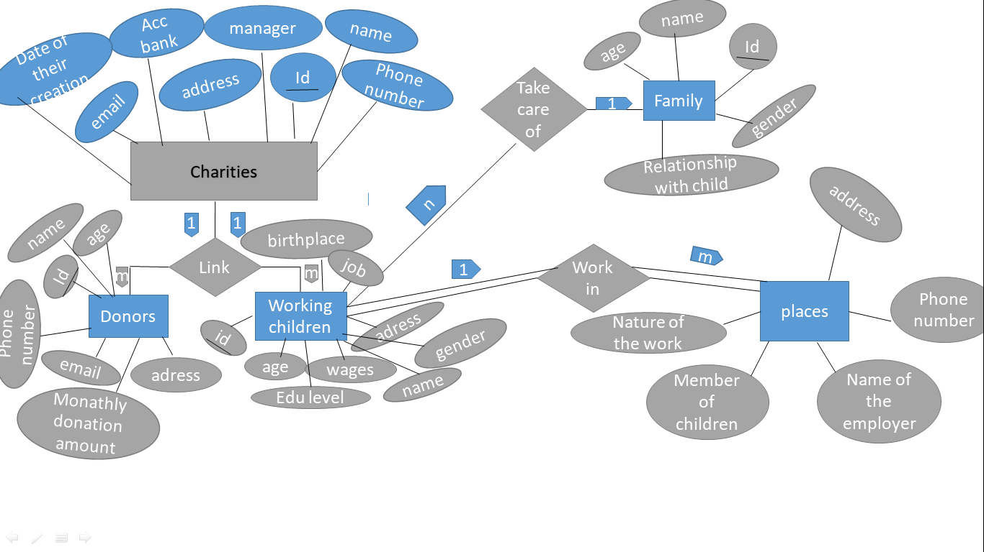**5.1. Conceptual data model**

**5.2. Relational data model**

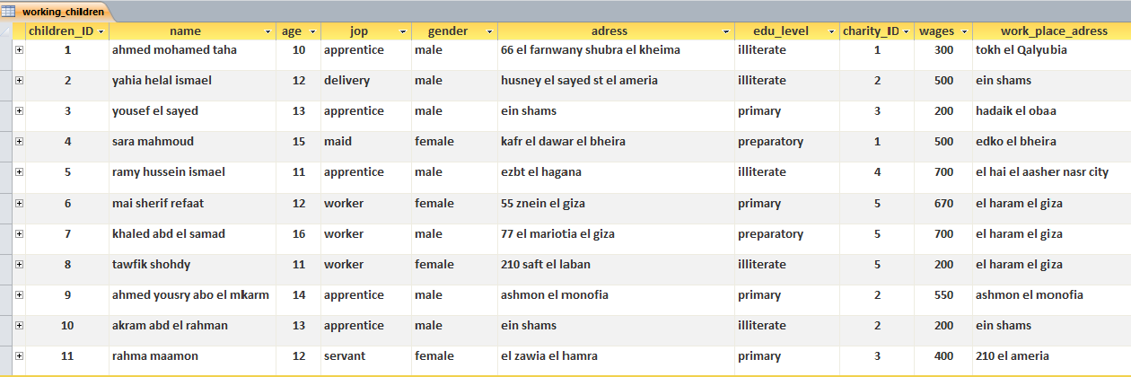

**2. Table of families**

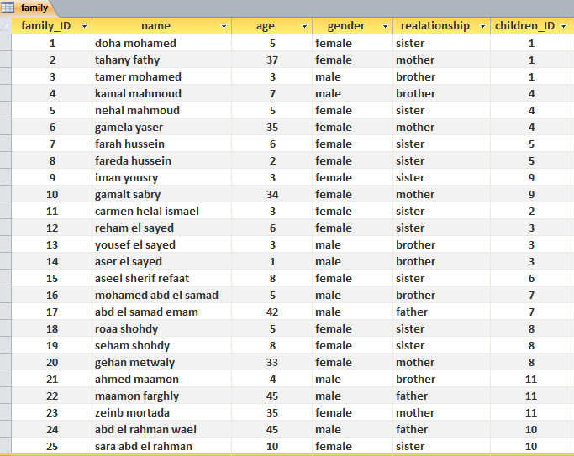

**3. Table of work places**

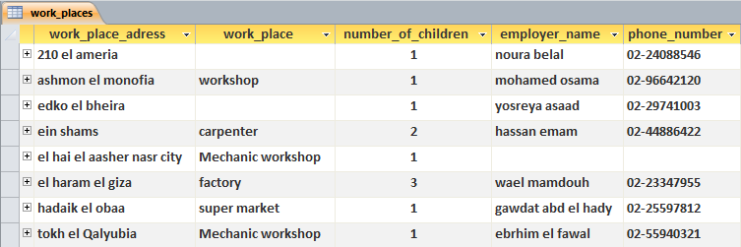

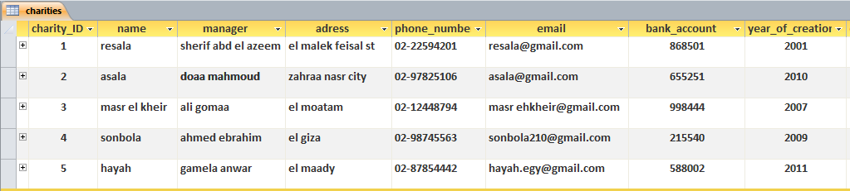**4. Table of charities**

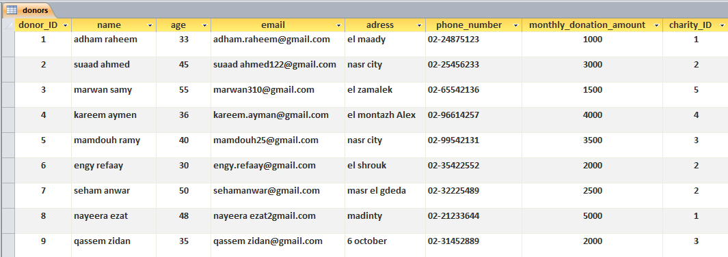**5. Table of donors**

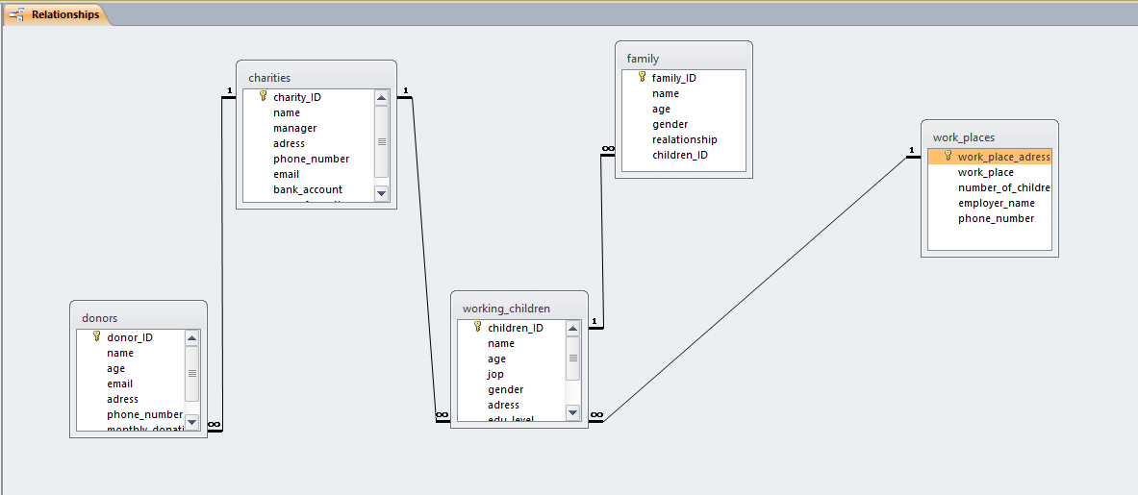**6. Relationship between tables**

**6. System Output:**

* Select the girls only from the children

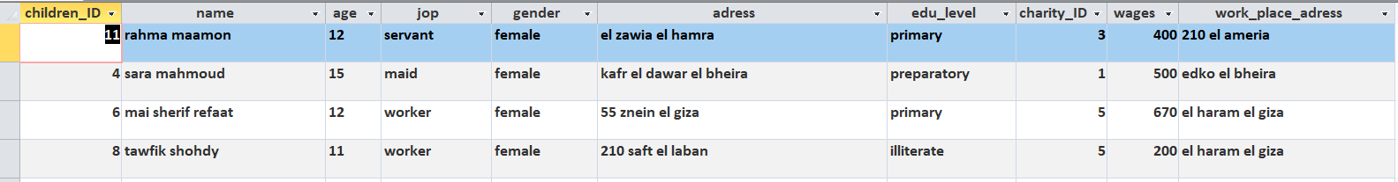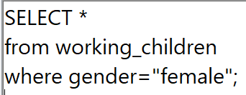

* Select children from age (12-15)who had some education

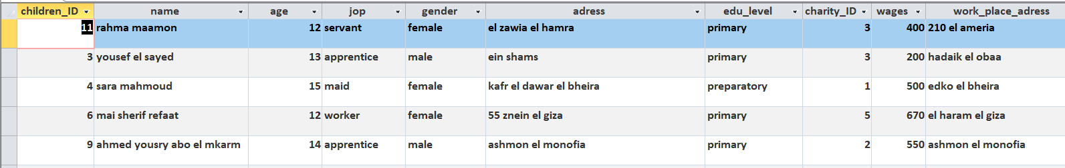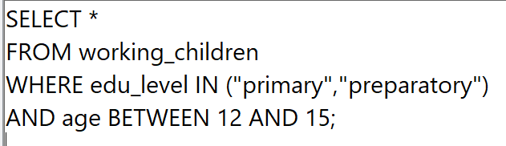

* Select children from age (10-15) and their wage is less than 500

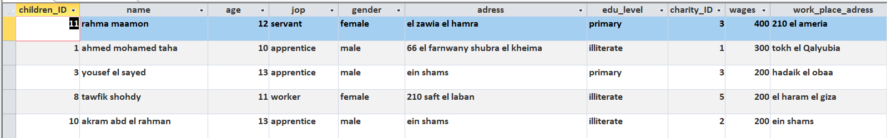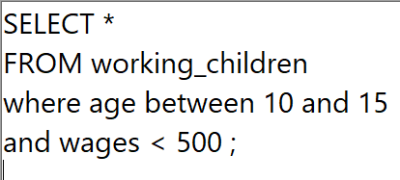

* 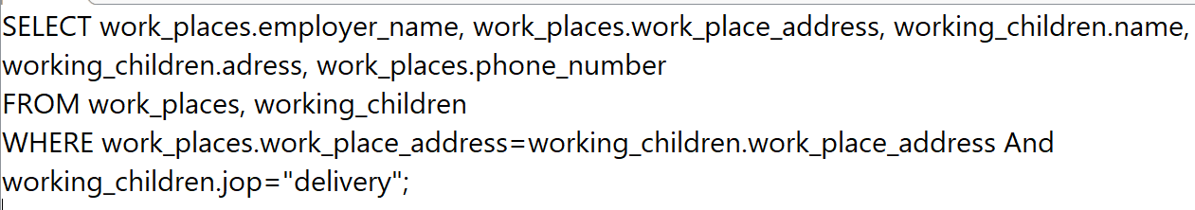select children who work in delivery and their work place address
* Select asala charity’s children and donors’ names

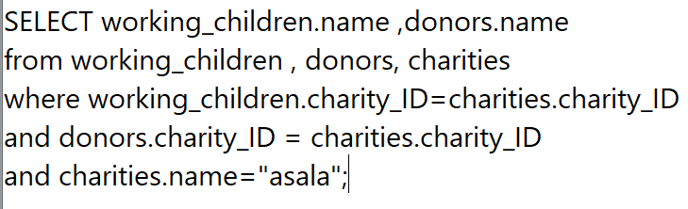

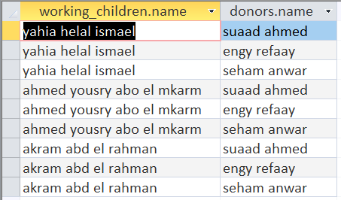

* Summation of donation

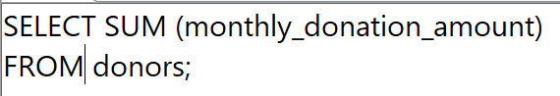

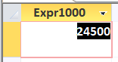

* 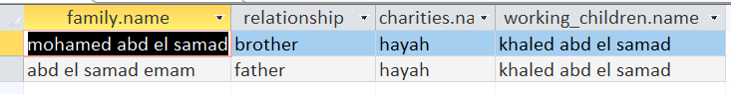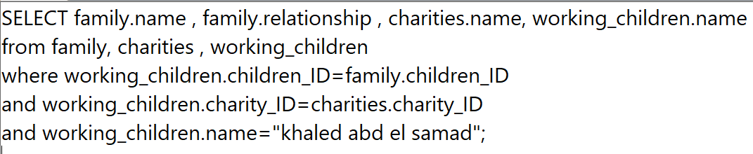Select the family of Khaled abd el samad and the charity that fosters their child

**7. Conclusion and Further Research Ideas:**

The child labor applied information system was designed out of a need to minimize the number of working children and providing them a decent life, through finding charities, orphanages, or people that are willing to help. This application should be available for everyone because that way it will help a larger number of children and their families and will also improve the social standards of life in Egypt. Based on the output generated, it can be concluded that this information system is easy to use and can make information management of working children easier and more present to all customers using the application (Organizations that are willing to provide the help needed).

Further Ideas can be added for this application is it can be linked to other ministries and organizations to provide the help needed in issues related to the child labor issue, the application should provide a filing a report feature in the case of finding an employer of a child who abuses him\her or forcing him\her to work and the application would be connected to the nearest police station in the area.

Another idea which would make the system even better is linking the application to social media as it has the ability to impact individuals and affect their decision-making process and also make mindfulness about the issue and any other issues related to this one. Social media can be utilized to get the help of the majority for the issue through focusing on a larger scope of people.